SUMMER INTERNSHIP REPORT
A Study of Equity Dealing Operations, Trading Terminals and Cash & Derivatives Market Practices at Rosy Blue Securities Pvt. Ltd.
Submitted in partial fulfilment for the award of the degree of
MASTER OF MANAGEMENT STUDIES
FINANCE
UNIVERSITY OF MUMBAI

Student | Details
Name | Nikhil Udaypratap Singh
Roll No. | M16158
Programme | MBA / MMS – Finance
Academic Year | 2025–2026
Company | Rosy Blue Securities Pvt. Ltd., Mumbai
Department | Equity Dealing Desk (Broking Operations – Equity)
Internship Period | 10 May 2026 to 09 July 2026
Project Guide | Dr. Rahul N. Wadekar

CERTIFICATE
This is to certify that Mr. Nikhil Udaypratap Singh, Roll No. M16158, student of Master of Business Administration (MBA) – Finance, Semester III, Navinchandra Mehta Institute of Technology and Development, University of Mumbai, has successfully completed his Summer Internship Programme at Rosy Blue Securities Pvt. Ltd., Mumbai, as an Equity Dealer in the Equity Broking & Dealing Department.
The internship was completed during the period from 10 May 2026 to 09 July 2026.
The student has prepared the internship report titled “A Study of Equity Dealing Operations, Trading Terminals and Cash & Derivatives Market Practices at Rosy Blue Securities Pvt. Ltd.” as a part of the academic requirements of the MBA – Finance programme.
During the internship, the student gained practical exposure to equity dealing operations, handling of trading terminals (NEAT Plus and CTCL), Cash Market and Futures & Options (F&O) Market operations, execution of buy/sell orders on behalf of clients as per their instructions, option trading strategies, trading charts and technical analysis, and dealing-room coordination and compliance processes.
Signatory | Designation
Dr. Rasika Mallya | Director
Dr. Rahul N. Wadekar | Project Guide
External Examiner | External Examiner

DECLARATION
I, Nikhil Udaypratap Singh, Roll No. M16158, hereby declare that the Summer Internship Programme report titled “A Study of Equity Dealing Operations, Trading Terminals and Cash & Derivatives Market Practices at Rosy Blue Securities Pvt. Ltd.” has been prepared by me as a part of the academic requirements of the MBA – Finance programme of the University of Mumbai.
This report is based on my learning, observations and practical exposure during my two-month internship at Rosy Blue Securities Pvt. Ltd., in the Equity Dealing Department, from 10 May 2026 to 09 July 2026.
The information presented in this report is intended for academic purposes. Confidential information such as client IDs, client order details, trade data, terminal credentials, passwords, proprietary trading strategies, RMS and compliance parameters and other sensitive dealing-room information has not been disclosed. All client names, order quantities and trade prices have been anonymized or excluded.
I further declare that this report has not been submitted previously to any other institution or university for the award of any degree or qualification.
Field | Entry
Name | Nikhil Udaypratap Singh
Roll No. | M16158
Place | Mumbai
Date | ____________

ACKNOWLEDGEMENT
I would like to express my sincere gratitude to everyone who supported me during my Summer Internship Programme at Rosy Blue Securities Pvt. Ltd.
First, I would like to thank my company mentor, Mr. Prateek Shah, Senior Equity Dealer, for his guidance, support and valuable inputs throughout the internship. His practical explanations helped me understand the working of dealing terminals, order execution in Cash and F&O segments, and the importance of accuracy, speed and compliance in client trade execution.
I am also thankful to the entire Equity Dealing team at Rosy Blue Securities Pvt. Ltd. for giving me an opportunity to learn through practical exposure. Working with the team helped me understand various aspects of NEAT Plus and CTCL terminals, market-watch creation, order placement and modification, Cash Market and F&O Market mechanics, client order flow, option strategies, and trading charts and technical analysis.
I would also like to thank the faculty members and management of Navinchandra Mehta Institute of Technology and Development for providing the academic framework and opportunity to undertake this Summer Internship Programme.
The internship helped me connect my classroom knowledge of finance, capital markets and derivatives with actual dealing-room practices and improved my communication, analytical thinking, decision-making under pressure, and professional skills.

EXECUTIVE SUMMARY
The Summer Internship Programme is an important part of the MBA curriculum because it provides practical exposure to concepts learned in the classroom. I completed my two-month internship at Rosy Blue Securities Pvt. Ltd., Mumbai, as an Equity Dealer on the Equity Dealing Desk, from 10 May 2026 to 09 July 2026.
The internship provided practical exposure to Equity Dealing Operations with a combination of market-facing and system-based responsibilities. My work involved operating trading terminals including NEAT Plus and CTCL, handling Cash Market and Futures & Options (F&O) Market orders, executing buy and sell transactions on behalf of clients strictly as per their instructions and guidance, and managing the complete order lifecycle from order receipt to trade confirmation.
I also gained hands-on understanding of Cash Market mechanics (intraday, delivery, settlement T+1, corporate actions), F&O Market structure (futures, options, lot size, expiry, margin, mark-to-market), option trading strategies (covered call, protective put, long straddle/strangle, bull call spread, bear put spread and iron condor concepts), and the use of trading charts and technical indicators (candlestick patterns, OHLC, volume, moving averages, RSI, MACD, Bollinger Bands, support and resistance). Regular interaction with the dealing desk reinforced risk controls, exposure monitoring, and compliance requirements.
In addition to daily client order execution, I supported colleagues in handling large or complex orders, participated in pre-market preparation and post-market reconciliation, and assisted in explaining terminal features, order types and basic chart reading to new team members. On an average, I assisted in handling and monitoring 15–18 client orders per day across Cash and F&O segments under supervision.
Overall, the internship helped bridge the gap between MBA Finance theory (financial markets, derivatives, portfolio management, technical analysis) and practical equity broking operations, while strengthening communication, discipline, time-management, analytical and client-handling skills essential for a dealing room.

INTERNSHIP AT A GLANCE
The following snapshot summarises the numerical information directly associated with the internship scope and the responsibilities described in this report. All figures are derived from the internship schedule and the dealing work described herein, not from external market data.
Metric | Value | Interpretation
Internship duration | 2 months | 10 May 2026 to 09 July 2026
Approx. daily client orders handled | 15–18 | Average orders assisted / monitored per day under supervision (Cash + F&O)
Major role groups | 4 | Terminal operations, market execution, analytical support, client service
Terminals & segments covered | 4 | NEAT Plus, CTCL, Cash Market, F&O Market
Primary function | Equity Dealing Operations | Buying/selling on behalf of clients as per guidance with compliance

INDEX
Sr. No. | Particulars | Page No.
1 | Introduction | 9
2 | Company Profile – Rosy Blue Securities Pvt. Ltd. | 10
3 | Industry and Functional Overview | 11
4 | Objectives of the Internship | 12
5 | Department Overview – Equity Dealing Desk | 13
6 | Roles and Responsibilities | 14
7 | Trading Terminals – NEAT Plus & CTCL | 15
8 | Cash Market & Futures & Options (F&O) Market | 16
9 | Trading Execution on Behalf of Clients | 17
10 | Option Trading Strategies | 18
11 | Trading Charts and Technical Analysis | 19
12 | Client Interaction & Order Management | 20
13 | Skills and Learning Outcomes | 21
14 | Detailed Work Analysis | 22
15 | Technical Concepts Learned | 23
16 | Operational Workflow and Risk Controls | 24
17 | Order Classification and Handling Framework | 25
18 | MBA Finance Linkage | 26
19 | Professional Development | 27
20 | Challenges and Problem-Solving Approach | 28
21 | Observations and Findings | 29
22 | Conclusion and Suggestions | 30
23 | Bibliography | 31
24 | Appendix – Activity Matrix | 32

1. INTRODUCTION
The Summer Internship Programme is designed to provide practical exposure to the working environment and to help students connect academic concepts with real organisational practices. As an MBA – Finance student, the internship provided an opportunity to understand the operational and market-facing side of equity broking, particularly how orders are originated by clients and executed in live markets through professional dealing terminals.
I completed my two-month internship at Rosy Blue Securities Pvt. Ltd., Mumbai, as an Equity Dealer on the Equity Dealing Desk. The role involved live-market execution work, including operating NEAT Plus and CTCL terminals, handling Cash and F&O orders, executing trades on behalf of clients as per their explicit instructions, interpreting trading charts, and understanding option strategies used by clients for hedging and speculation.
The internship environment provided exposure to day-to-day dealing-room operations where accuracy, speed, attention to detail, communication and risk awareness were critical. Orders could relate to intraday or delivery trades in the Cash segment, futures and options in the F&O segment, market/limit/stop-loss order types, lot-size and expiry handling, margin and exposure checks, as well as chart-based decision support communicated to clients.
The experience demonstrated that successful equity dealing is not limited to market knowledge alone. Technology (trading terminals and order management systems), disciplined processes, client communication, chart interpretation and compliance controls work together to ensure fair, timely and accurate execution in a fast-moving market environment.
Key Points
- Practical exposure to Equity Dealing Operations at a broking house
- Hands-on operation of NEAT Plus and CTCL trading terminals
- Cash Market & F&O Market order execution on behalf of clients
- Option trading strategies and trading charts / technical analysis
- Client communication, order management, risk and compliance discipline

2. COMPANY PROFILE – ROSY BLUE SECURITIES PVT. LTD.
Rosy Blue Securities Pvt. Ltd. was the organisation where I completed my Summer Internship Programme. I was associated with the Equity Dealing Desk at the Mumbai location. My internship exposure was primarily related to equity broking, dealing-room operations and client trade execution in both Cash and Derivatives segments.
The internship gave me an opportunity to observe how a SEBI-registered stock-broking firm operates within the exchange ecosystem (NSE/BSE). The broking house acts as an intermediary that provides clients with market access, research inputs, dealing support and execution services, while ensuring compliance with exchange regulations, client code mapping, order validation, risk management and settlement coordination. The work required coordination between clients, dealers, risk/compliance teams and the exchange trading system, especially when market volatility or large orders required quick yet controlled action.
Within the scope of the internship, I worked on NEAT Plus and CTCL terminal operations, Cash Market and F&O Market execution, client order handling (buy/sell as per client guidance), understanding of option strategies, and interpretation of trading charts and indicators. The role also involved shadowing senior dealers, observing pre-market planning, live-market execution and post-market reporting, and assisting with knowledge sharing for new joiners.
Because the work involved live client orders and market-sensitive information, confidentiality and compliance were paramount. Sensitive information such as client identities, actual order quantities, executed prices, terminal IDs/passwords, and proprietary dealing procedures has been intentionally excluded from this academic report, and all examples are illustrative.
Key Points
- Organisation: Rosy Blue Securities Pvt. Ltd.
- Location: Mumbai – Equity Dealing Desk
- Function: Equity Dealing / Equity Broking Operations
- Internship duration: 10 May 2026 to 09 July 2026

3. INDUSTRY AND FUNCTIONAL OVERVIEW
The Indian capital market ecosystem comprises exchanges (NSE, BSE), depositories (NSDL, CDSL), brokers, clearing corporations and regulators (SEBI). Within this ecosystem, equity broking and dealing is a critical function that connects investors/traders with the exchange order book. Clients depend on brokers for reliable terminal access, correct order placement, timely execution, transparent confirmations, and compliant settlement, particularly when they are not directly placing orders themselves but routing instructions to a dealer.
From my internship experience, Equity Dealing can be understood as a bridge between clients and the exchange. A client instruction – whether for a Cash intraday/delivery trade or an F&O futures/options position – begins as a communication (call, chat or OMS instruction), is then validated for client code, segment, scrip/contract, quantity, price, order type and margin/exposure, and is finally punched into the terminal (NEAT Plus or CTCL) for matching on the exchange. The dealer monitors the order book, market depth, price action and trading charts, confirms execution or modification/cancellation, and communicates fills back to the client.
Cash Market and F&O Market require different operational disciplines. Cash Market involves understanding tick size, circuit filters, intraday (MIS) versus delivery (CNC), settlement T+1, auction and corporate actions. F&O Market adds lot size, expiry (weekly/monthly), strike selection, premium versus intrinsic value, time decay (theta), and margin requirements (SPAN + exposure) that directly impact whether an order can be accepted. Similarly, trading terminals require familiarity with market watch, order window, trade book, net position, and risk alerts, while charts require reading of candlesticks, trends and indicators to contextualise client discussions.
The internship therefore provided practical understanding of how broking operations combine market knowledge, terminal technology, chart interpretation and disciplined dealing processes to serve clients in a technology-driven, highly regulated environment.
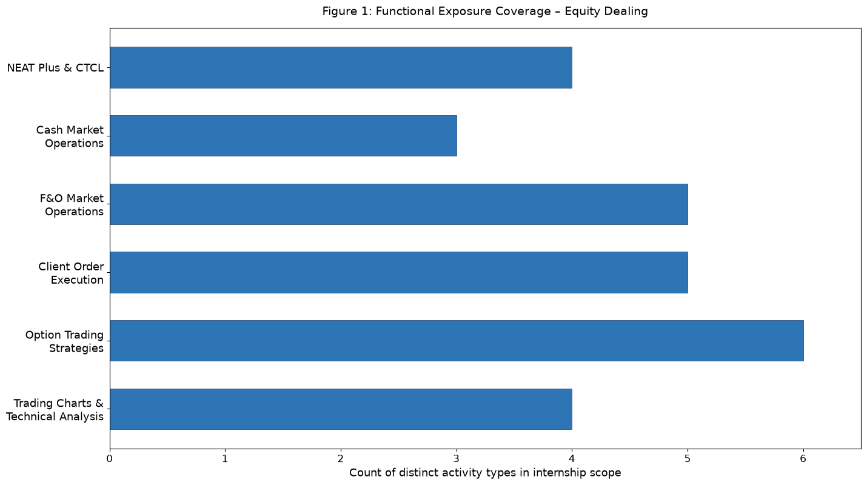
Figure 1: Functional exposure coverage based on the distinct activity items handled during the internship at Rosy Blue Securities (count of activity types per functional area).

4. OBJECTIVES OF THE INTERNSHIP
The primary objective of the internship was to gain practical exposure to Equity Dealing at a broking house and understand how trading terminals, market segments and client instructions are coordinated in a live-market environment.
The internship also aimed to develop the ability to operate NEAT Plus and CTCL terminals confidently, understand Cash Market and F&O Market mechanics, receive and validate client buy/sell instructions accurately, execute and monitor orders, and communicate execution status clearly while observing risk and compliance controls.
Another objective was to understand option trading strategies (directional, hedged and neutral approaches) and trading chart analysis (price patterns, volume and technical indicators) at a practical, dealer-oriented level – not for personal speculation, but to follow client intent, explain risk-reward, and translate chart-based contexts into precise order actions as guided by clients.
Key Points
- Understand Equity Dealing and broking-house dealing-room operations
- Learn NEAT Plus & CTCL trading terminal operations and order types
- Understand Cash Market and F&O Market structure and execution
- Gain exposure to client order handling – buying/selling as per client guidance
- Develop understanding of option strategies and trading charts
- Build client communication, risk awareness and compliance discipline

5. DEPARTMENT OVERVIEW – EQUITY DEALING DESK
The Equity Dealing Desk at Rosy Blue Securities Pvt. Ltd. is the client-facing execution arm of the broking business. During my internship, the desk functioned as a high-attention, time-sensitive environment where dealers received client instructions, validated them against client codes, limits and market conditions, punched orders on NEAT Plus/CTCL, monitored order and trade books, and provided confirmations. Pre-market preparation (global cues, watchlists, corporate actions, F&O expiry calendars) and post-market activities (position reconciliation, trade confirmations, exposure reporting) were also integral.
The desk required a balance between market understanding, terminal proficiency and operational discipline. A dealer needs to understand the nature of the client instruction (scrip/contract, side, quantity, price, product type), verify risk constraints, decide the appropriate terminal and order type (market, limit, stop-loss, stop-limit, IOC, etc.), track execution quality, and escalate or modify/cancel as per further client guidance, all while maintaining clear, timestamped communication.
The work environment was strongly team-oriented. Complex or large orders were discussed with senior dealers for slicing or timing considerations, and knowledge was shared on terminal shortcuts, chart reading, and F&O lot/expiry handling to improve speed and consistency across the desk. Peer cross-checks and dealer discipline reduced errors in a high-stakes setting.
Key Points
- Client instruction intake and validation
- Order placement and monitoring on NEAT Plus / CTCL
- Trade confirmation and post-trade coordination
- Risk, margin and compliance checks
- Team collaboration and knowledge sharing in live market

6. ROLES AND RESPONSIBILITIES
During my two-month internship at Rosy Blue Securities Pvt. Ltd., I worked as an Equity Dealer (Trainee) on the Equity Dealing Desk and handled a combination of terminal-based, market-related and client-service responsibilities under supervision. My work was focused on learning to operate dealing terminals, executing client-guided Cash and F&O orders, and understanding charts and option strategies that inform client decisions.
My key responsibility was to learn and operate trading terminals – NEAT Plus (NSE’s dealer terminal) and CTCL (Computer to Computer Link) – covering market-watch creation, scrip/contract search (including F&O symbol, strike, expiry selection), order entry and modification/cancellation, trade book and net position monitoring, and basic troubleshooting such as login, password, and connectivity checks in coordination with IT/support.
I also assisted in Cash Market and F&O Market operations: handling Cash segment orders (intraday/leverage versus delivery/CNC, understanding circuit limits and auction risk), and F&O segment orders (index and stock futures, index and stock options – calls and puts), with attention to lot size, expiry week/month, strike intervals, premium, margin and Mark-to-Market (MTM) concepts, and the necessity of square-off or roll-over before expiry.
Along with order execution, I was engaged in buying and selling on behalf of clients strictly as per their guidance – whether an instruction to buy a Cash equity for delivery, sell an intraday position, buy a futures contract, or buy/sell option contracts. This involved confirming client intent, punching the exact order as instructed, monitoring fills, communicating executed price/quantity and brokerage, and maintaining an audit trail without offering unauthorised personal advice.
I also focused on learning option trading strategies and trading charts: studying strategy pay-offs and risk-reward (for example, when a client discussed a straddle or spread), and reading candlestick charts, trends, volume, moving averages, RSI, MACD and Bollinger Bands to contextualise market movement and support senior dealers in client conversations, always as guided by clients/seniors.
Responsibility group | Representative activities
Trading Terminal Operations | NEAT Plus, CTCL, market watch, order entry/modification, trade book & net position monitoring
Market Operations | Cash Market (intraday/delivery, T+1, circuits) & F&O Market (futures, options, lots, expiry, margins, MTM)
Client Execution | Buy/sell orders on behalf of clients as per instructions, validation, confirmation & audit trail
Analytical & Team Support | Option strategies, trading charts/technical analysis, peer learning and knowledge sharing

7. TRADING TERMINALS – NEAT PLUS & CTCL
Trading terminals are the primary interface between the dealer and the exchange order book. NEAT Plus (NSE’s dealer front-end) and CTCL (an alternative front-end that provides additional flexibility and speed) were the two terminals I learned and operated under supervision. Both terminals connect to the exchange via approved CTCL/NNF infrastructure and require valid dealer/user IDs, passwords and exchange approvals.
One aspect of the work involved mastering the market watch, order book and trade book. I learned to create segment-wise market watches (Cash, F&O), add scrips/contracts correctly (e.g., RELIANCE EQ for Cash, RELIANCE 25JUN2026 1500 CE for Options), interpret bid-ask spread, depth and last traded price (LTP), place orders via the order window (selecting client code, scrip, quantity, price, order type), and monitor order status (open, pending, executed, rejected) and net position throughout the session.
Order types and order management formed another important area. I practiced market orders (execution at best available price), limit orders (with specified price), stop-loss orders (SL and SL-M with trigger price), and Immediate-or-Cancel (IOC) concepts, understanding when each is appropriate based on client instruction and liquidity. I also learned modification (price/qty change before execution) and cancellation, and the importance of not duplicating or mishandling orders during fast markets.
Terminal controls and access management were also part of the learning. This included secure login/logout discipline, understanding user IDs versus client codes versus trading member mapping, awareness of exchange trading hours (pre-open, normal market, post-close), and the role of RMS (Risk Management System) alerts – such as exposure limit breach, insufficient margin, or circuit freeze – that block or queue an order before it reaches the exchange.
Through this work, I learned that terminal proficiency is not just about speed; it is about accuracy, confirmation discipline and compliance – punching exactly what the client instructed, double-checking before confirming, and maintaining a clear communication trail.
Key Points
- Market-watch creation and scrip/contract search (Cash and F&O)
- Order placement, modification and cancellation on NEAT Plus / CTCL
- Understanding order types: market, limit, stop-loss, IOC and trigger price
- Login, user ID/client code mapping and exchange session awareness
- Risk alerts, exposure checks and compliance before order punch

8. CASH MARKET & FUTURES & OPTIONS (F&O) MARKET
During the internship, I gained practical exposure to both Cash Market and F&O Market operations, which together form the core of retail and HNI participation at a broking house. Understanding their differences was essential because client instructions, margin treatment and risk differ markedly across segments, and a dealer must select the correct segment, product and order parameters before execution.
Cash Market exposure included intraday trading (Margin Intraday Square-off/MIS) versus delivery-based investing (Cash-and-Carry/CNC): intraday provides leverage and requires compulsory square-off before market close, while delivery involves full payment, T+1 settlement and demat credit, with exposure to corporate actions (splits, bonuses, dividends) and auction risk if delivery fails. I learned to check circuit filters (upper/lower), price bands, opening/closing price discovery, and to recognise illiquid scrips where market orders carry high slippage – prompting confirmation of limit prices with clients.
F&O Market exposure covered futures and options on index (e.g., NIFTY, BANKNIFTY, FINNIFTY) and on individual stocks. For futures, I learned about contract lots, contract value, expiry (weekly for indices, monthly for stocks), Mark-to-Market settlement and the concept of cost-of-carry. For options, I learned the distinction between calls (right to buy) and puts (right to sell), strike selection, premium versus intrinsic/extrinsic value, moneyness (ITM/ATM/OTM), time decay (theta) and volatility impact, as well as the obligation for writers (sellers) versus limited risk for buyers of options (premium paid).
Settlement, margin and risk controls linked both segments. Cash Market requires funds/securities upfront for delivery; F&O requires initial SPAN + exposure margin blocked per lot, with additional MTM for futures and short options, and physical settlement risk for stock F&O on expiry. As a dealer, I learned to check with the RMS/compliance view whether a client’s ledger and margin permitted the order, explain margin calls or position limits if an order was rejected, and emphasise timely square-off to avoid auction or physical delivery.
Key Points
- Cash Market: intraday vs delivery, T+1 settlement, circuits & corporate actions
- F&O futures: lots, expiry, contract value and MTM
- F&O options: calls/puts, strike, premium, ITM/ATM/OTM and Greeks introduction
- Margining: SPAN + exposure, MTM and leverage discipline
- Segment selection, product type and timely square-off on expiry

9. TRADING EXECUTION ON BEHALF OF CLIENTS (BUYING & SELLING)
Trading execution is the core dealing activity where the dealer acts strictly as an agent executing buy and sell orders on behalf of clients as per their explicit guidance. At Rosy Blue Securities Pvt. Ltd., I was engaged in receiving client instructions (typically via recorded phone lines/approved chat/OMS), re-confirming the details verbally, punching the order on NEAT Plus or CTCL, monitoring the order book until the trade was filled or modified/cancelled per further guidance, and confirming back the execution details to the client.
I learned the standard dealing protocol: (a) verify client code and segment, (b) confirm scrip/contract (with correct symbol, strike, expiry for F&O), side (buy/sell), quantity/lots and price/order type, (c) check RMS exposure/margin and market status (pre-open/open/circuit) before punching, (d) place order and announce order number, (e) track partial fills and average price, and (f) provide post-trade confirmation (quantity executed, average price, brokerage/taxes, net obligation) and ensure audit trail for compliance.
Orders varied in nature: a client might instruct “Buy 100 shares of TCS in Cash delivery at limit ₹3,450,” or “Sell 2 lots of NIFTY 24JUL 24000 CE at market,” or “Square-off my intraday long in Infosys at market.” Each required exact interpretation – whether Buy to open/close, Sell to close/open, intraday versus carry-forward, market versus limit – and precise action without assumption. Any ambiguity was clarified with the client before execution, and no order was modified without fresh instruction, ensuring compliance and avoiding mis-execution.
This experience improved my ability to handle pressure during volatile opens and expiry days, to listen actively and repeat-back instructions, to avoid fat-finger errors (wrong scrip/price/qty) through pre-punch verification, and to maintain calm, structured communication even when markets were fast. I learned that execution quality – accurate price, full/partial fill handling, timely communication – defines client trust in a broking relationship.
Key Points
- Receiving and re-confirming client instructions (scrip, side, quantity, price)
- Verifying client code, segment, product and RMS margin/exposure before punch
- Punching orders on NEAT Plus / CTCL and monitoring order/trade book
- Handling market, limit, stop-loss and modification/cancellation as guided
- Post-trade confirmation and audit trail for compliance

10. OPTION TRADING STRATEGIES
Option trading strategies were a distinctive learning area during the internship, because many clients active in the F&O segment use multi-leg option structures for hedging, directional views or premium collection, and a dealer must understand what the client is trying to achieve to execute the correct legs at the intended strikes/expiry. Learning was observational and educational under senior dealers, with no discretionary trading without client instruction.
I was introduced to foundational strategies and their pay-offs: single-leg long call/put (directional with limited risk for buyer), covered call (holding Cash delivery + selling call), protective put (holding Cash + buying put for downside protection), spreads (bull call spread – buy lower strike call, sell higher strike call; bear put spread – buy higher strike put, sell lower strike put), and volatility strategies like long straddle (buy ATM call + put of same expiry) and long strangle (buy OTM call + put). Iron condor and butterfly concepts were also explained as limited-risk premium strategies involving four legs.
For each strategy, I learned to analyse risk-reward: maximum profit/loss, breakeven points, margin requirement (especially for writers who collect premium but face potentially large MTM), time decay impact and the role of implied volatility (IV). For example, a long straddle benefits from a large move in either direction but suffers from time decay if the market stays sideways, while a bull call spread caps both profit and loss compared to a naked long call.
Practical dealing aspects included ensuring correct strike/expiry selection, verifying lot size per leg, checking margin adequacy for multi-leg orders (span margin often reduced for hedged positions but still required), handling execution of legs sequentially or as a spread order if available, and confirming fills leg-wise with the client. Charts and OI data were often referenced alongside strategies to discuss trend or support/resistance contexts, again only as guided by clients/seniors.
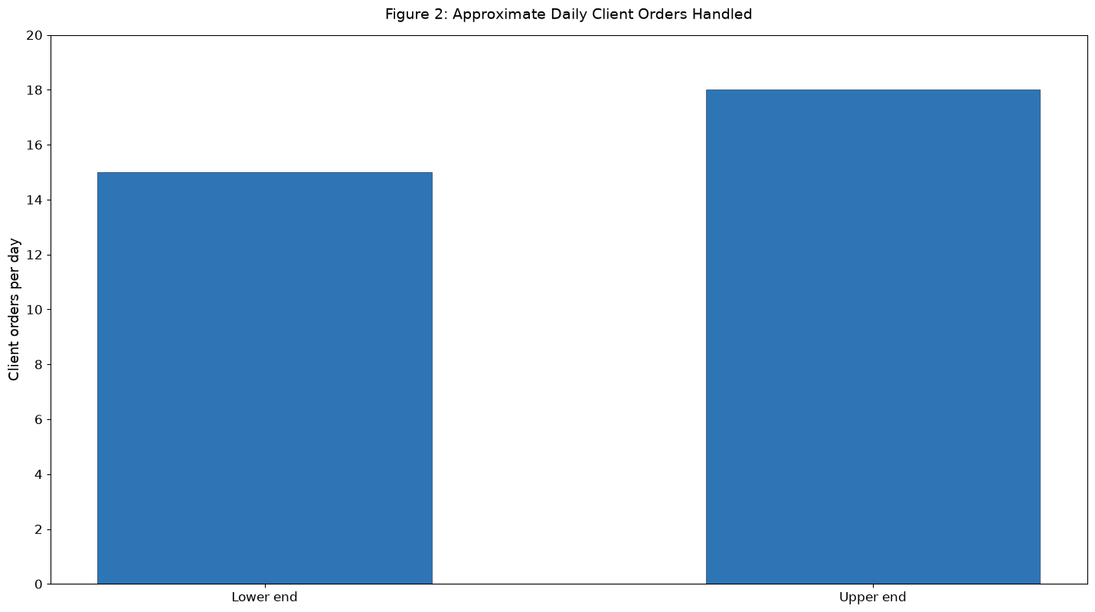
Figure 2: Approximate daily client orders handled during the internship (range of 15–18 orders per day under supervision).

11. TRADING CHARTS AND TECHNICAL ANALYSIS
Trading charts translate price and volume history into visual patterns that help dealers and clients contextualise market behaviour and discuss levels, though the final order instruction always remains client-driven. During the internship, I learned to read and interpret core charting tools used on the dealing desk, primarily to understand what a client meant when referencing a breakout, support or indicator signal.
I learned candlestick fundamentals – OHLC (Open, High, Low, Close) representation, body versus wick, bullish versus bearish candles, and volume accompanying price – and then progressed to commonly watched patterns: Doji, Hammer, Shooting Star, Engulfing, and trend-based patterns such as Head-and-Shoulders, Double Top/Bottom, Triangles and Flags. Support (demand) and resistance (supply) zones were drawn using swing highs/lows, and trendlines and channels helped describe whether a market or scrip was trending, ranging or reversing.
Technical indicators added a second layer: moving averages (SMA/EMA – e.g., 20, 50, 200-day) for trend, RSI for momentum and overbought/oversold (70/30 thresholds), MACD for trend-momentum crossovers, Bollinger Bands for volatility and price extremes, and VWAP for intraday average price benchmarking. I practiced reading them on Cash scrips and F&O underlyings, understanding that no single indicator is decisive and that confluence (e.g., price near support + RSI oversold + bullish engulfing) is often discussed before a client decides to buy, sell or avoid.
The key professional learning was to use charts as a communication and risk-awareness tool rather than a prediction guarantee – to help explain to a client why a stop-loss level might be placed below support, or why a breakout above resistance with high volume was being watched, while always acknowledging market risk and executing only as per the client’s final instruction.
Key Points
- Candlestick, OHLC, volume and support/resistance reading
- Pattern recognition: trends, reversals and consolidation
- Moving averages, RSI, MACD, Bollinger Bands and VWAP
- Using charts for stop-loss, breakout and trend context
- Chart-guided discussion without unauthorised advice – client instruction prevails

12. CLIENT INTERACTION & ORDER MANAGEMENT
Client interaction in a dealing room is governed by clarity, recording and compliance. During the internship, I observed and assisted in the full order-management cycle: client initiation → dealer validation & punch → exchange matching → dealer confirmation → back-office settlement and ledger update, with compliance recording at each step.
Sessions began with pre-market checks – reviewing previous day positions, corporate actions, F&O expiry and ban lists, and preparing watchlists – so that when markets opened, scrip codes, lot sizes and circuit limits were ready. In live market, I learned to handle queued instructions, prioritise by client seniority/risk, and manage partial fills (e.g., only 60% of order quantity executed) by reconfirming with the client whether to keep the balance open, modify price, or cancel the remainder.
Communicating execution clearly was critical: after a fill, the dealer confirms executed quantity, average price, remaining pending quantity, brokerage and net obligation, and timestamps the communication. For F&O, additional details such as expiry and strike were always repeated. I also learned the importance of escalation: if an order was rejected due to insufficient margin, circuit, or trading halt, the dealer calmly explains the RMS/compliance reason and suggests, if asked, alternative order types strictly upon client re-instruction.
This responsibility strengthened my professional etiquette – speaking concisely on recorded lines, maintaining composure during heavy volatility, logging every instruction and avoiding any promise of returns or guarantee of execution price in fast markets.
Training topic | Coverage
NEAT Plus / CTCL | Terminal interface, market watch, order window, order types, trade book and RMS alerts
Cash & F&O Markets | Cash intraday/delivery and F&O futures/options, lots, expiry, strike, premium, margins
Option Strategies | Single-leg, spreads, straddle/strangle, iron condor – pay-off, breakeven and risk
Trading Charts | Candlesticks, trends, support/resistance and indicators (MA, RSI, MACD, Bollinger, VWAP)
Client Dealing Process | Instruction validation, punch, monitoring, confirmation, compliance and audit

13. SKILLS AND LEARNING OUTCOMES
The internship resulted in learning across terminal, market, analytical and professional dimensions. I developed a practical, dealer-oriented understanding of how equity broking operations function in a live, highly regulated market environment.
Terminal and market learning included proficiency in NEAT Plus and CTCL terminal operations, Cash Market mechanics (intraday/delivery, T+1, circuits), F&O Market structure (lots, expiry, strike, margin, MTM), order types and their appropriate use, and the full buy/sell execution cycle on behalf of clients with strict adherence to their guidance.
Analytical learning included option trading strategies – from single-leg directional calls/puts to spreads, straddles, strangles and iron condor concepts – and trading chart/technical analysis – candlesticks, volume, trend, support/resistance and indicators (MA, RSI, MACD, Bollinger, VWAP) – enabling me to follow dealer-client strategy discussions and understand risk-reward pay-offs.
Professional learning included client communication under time pressure, teamwork with senior dealers, attention to detail to avoid punching errors, time management during opening and expiry, and respect for compliance, confidentiality and audit trails.
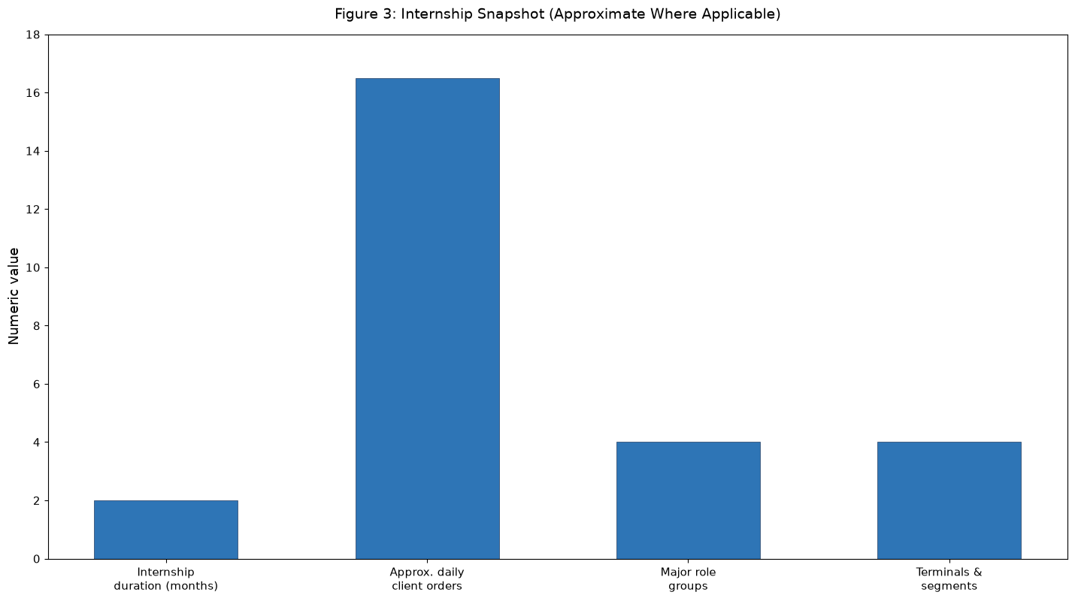
Figure 3: Internship snapshot using the quantitative details available from the internship scope. The 16.5 figure is a visual midpoint of the stated 15–18 daily client orders range.

14. DETAILED WORK ANALYSIS
The practical work performed during the internship can be understood through four connected dimensions: terminal operations, market execution, analytical support, and client-service/team enablement. Each dimension contributed to the overall objective of providing accurate, timely and compliant trade execution for clients of Rosy Blue Securities Pvt. Ltd.
Terminal operations focused on NEAT Plus and CTCL proficiency: login discipline, market-watch setup, scrip/contract identification, order entry/modification/cancellation, trade book and net position monitoring, and basic connectivity/RMS checks. Market execution covered Cash Market (intraday/delivery handling, circuit awareness, T+1 settlement) and F&O Market (futures, calls, puts, lot/expiry/strike handling, premium/MTM, margin checks) with strict price/qty validation before punch. Analytical exposure spanned option strategies and chart reading to contextualise client intent, while team enablement included supporting senior dealers with large orders, sharing terminal shortcuts, and explaining order types and chart basics to new joiners.
This layered exposure broadened my understanding from individual order handling to the wider dealing workflow – from pre-market preparation through live execution to post-market reconciliation – illustrating how a dealer’s minute-to-minute actions fit into the firm’s risk, compliance and client-trust framework.
The combined exposure helped me see how a dealer role contributes to continuity, responsiveness and process discipline in a technology-driven broking environment, where a single verified execution can reinforce long-term client confidence.
Work dimension | Examples from internship | Learning outcome
Terminal Operations | NEAT Plus/CTCL, market watch, order entry, trade book, RMS alerts | Terminal proficiency and execution discipline
Market Execution | Cash Market, F&O Market, buy/sell on behalf of clients as guided | Segment understanding and order-handling accuracy
Analytical Support | Option strategies, trading charts and indicators | Strategy and chart interpretation
Client & Team Enablement | Order validation, confirmation, peer support and knowledge sharing | Communication, teamwork and compliance

15. TECHNICAL CONCEPTS LEARNED
The internship introduced me to several technical concepts specific to exchange trading and broking technology. I developed practical familiarity with NEAT Plus and CTCL front-ends, CTCL/NNF connectivity basics, and the RMS layer that validates orders before they reach the exchange matching engine.
The Cash versus F&O distinction solidified concepts learned in MBA Finance – such as leverage, margin, hedging and speculation – by showing their live application: how delivery trades require full funding whereas intraday/MIS uses VaR-based margins, how futures MTM creates daily profit/loss settlement, and how option premium is influenced by intrinsic value, time to expiry and volatility (Greeks delta, gamma, theta, vega in simplified dealer terms).
I also learned the operational relevance of settlement cycles, auction and physical settlement risk in stock F&O, and the use of trading charts and indicators as decision-support tools. The learning was not limited to terminology; it involved translating a client’s phrase like “Buy NIFTY 24500 Call” into the exact contract (symbol NIFTY, instrument OPTIDX, option type CE, strike 24500, expiry 17JUL2026, lot 75) with correct product and validity.
The learning therefore connected exchange microstructure, broking technology and client execution into one coherent dealer skill set.
Key Points
- NEAT Plus & CTCL terminal concepts and order flow
- Cash Market and F&O (Futures & Options) microstructure
- Lot size, expiry, strike, premium, MTM and margins (SPAN + exposure)
- Order types and trigger logic
- Trading charts, candlesticks and technical indicators
- Risk checks and settlement awareness

16. OPERATIONAL WORKFLOW AND RISK CONTROLS
Operational controls in a dealing room exist to prevent errors and protect both client and broker. During the internship, I learned the standard workflow that must be followed repetitively even in fast markets, rather than improvising per order.
An important control is client and order validation: re-confirm client code, segment and scrip/contract, double-check quantity/lots versus lot size, verify product type (CNC/MIS/NRML) and order type, and glance at circuit/volume to flag illiquidity or price bands. The next control is risk validation: RMS checks for available margin/ledger balance, exposure limits, position limits and trading halts; a blocked order must be explained to the client, not bypassed. When an order requires compliance approval (e.g., large block), escalation must contain complete details for audit.
Follow-up is the third control: a punched order remains the dealer’s responsibility until a clear status (fully executed, partially executed with balance handled, cancelled or rejected) is communicated back to the client and logged. End-of-day controls include position reconciliation, trade confirmation files, and next-day margin/carry-forward checks.
This workflow improved my discipline – to pause and verify even when a client was urgent, to use repeat-back, and to maintain a log that would allow any trade to be traced to an instruction.
Key Points
- Re-confirm client and order details verbally before punch
- Validate segment, product, lot size and price/order type
- Pass RMS margin/exposure checks; explain blocks transparently
- Track order status to fill/cancel/reject and confirm to client
- Maintain log and audit trail for compliance
- Respect confidentiality and avoid unauthorised advice

17. ORDER CLASSIFICATION AND HANDLING FRAMEWORK
During the internship, the daily client order flow was approximately 15–18 orders handled/assisted per day under supervision. The orders could be grouped by the type of market, instruction and risk involved. The classification below is a framework for describing the dealing scope; it is not a statistical distribution of actual brokerage volume.
Cash intraday orders focused on same-day square-off with leverage; Cash delivery orders involved full payment and T+1 demat transfer. F&O futures orders (index/stock) and F&O options orders (buy call/put, sell call/put under permitted risk) involved lot-based execution and expiry awareness. Strategy-based instructions might refer to a spread or straddle where two legs must be handled in sequence, requiring careful coordination and leg-wise confirmations.
Using a classification framework helps a dealer decide what information to collect (e.g., strike/expiry for options), what checks to perform (margin for writers), and which compliance constraints apply. It also supports knowledge sharing because recurring instruction types can be documented as playbooks for new dealers.
Order category | Typical examples | First action check
Cash Intraday | Market/limit buy/sell for intraday square-off | Verify client code, scrip, quantity, product MIS and circuit
Cash Delivery | Delivery buy/sell (CNC) with T+1 | Verify funds/securities, scrip and settlement
F&O Futures | Index/stock futures buy/sell | Verify lot size, expiry, margin and MTM risk
F&O Options | Buy/sell calls & puts (single-leg or multi-leg) | Verify strike, expiry, premium, lot and writer margin
Strategy/Charts | Spread, straddle, chart-based level query | Confirm strategy legs, expiry and price/instruction as guided

18. MBA FINANCE LINKAGE
The internship provided a practical connection between MBA Finance learning and broking operations. Academic concepts such as equity valuation, efficient markets, derivatives pricing (Black-Scholes intuition), hedging, arbitrage, portfolio diversification and technical analysis became tangible when seen through live price action, margin calls, and client hedging requests.
The exposure to trading terminals and client execution helped me understand that capital-market theory is implemented through microstructure: bid-ask spreads, liquidity, order-matching, circuits, and settlement guarantee mechanisms. For example, the impact of volatility on option premium (vega) was no longer abstract when I saw a 5% India VIX spike inflate premiums intraday, or when theta decay eroded an OTM call’s value near expiry.
The internship also strengthened my understanding of operational risk – how a wrong strike, expiry or quantity can create unintended exposures, which is why dealer controls mirror risk-management theory (segregation of duties, four-eyes, limit monitoring) taught in class.
The experience therefore complemented classroom learning by showing how financial-market functions are operationalised and monetised within a broking firm while maintaining client trust and regulatory compliance.
Key Points
- Capital-market and derivatives concepts in live dealing
- Exchange microstructure in operation
- Risk-management and operational controls
- Importance of compliance and audit discipline
- Role of communication and ethics in market intermediation

19. PROFESSIONAL DEVELOPMENT
The internship contributed to my professional development beyond market knowledge. Regular live-market dealing improved my ability to listen carefully under pressure, identify the exact order intent, and respond with a structured, repeat-back confirmation that reduced misunderstandings, even when background noise and price volatility were high.
Supporting senior dealers with large or multi-leg orders improved teamwork and confidence in collaborative execution. Exposure to the risk team also helped me understand how responsibilities are shared – dealers focus on execution and communication, risk teams on exposure gating, and compliance on recording and reporting.
Explaining terminal features, market basics and chart reading to new joiners improved presentation and mentoring skills. I learned that knowing a feature and being able to teach it are different skills; teaching requires sequencing, anticipating doubts, and using simple examples without revealing confidential client data or guaranteeing outcomes.
The overall experience strengthened my readiness for roles that combine finance domain knowledge with market-facing, technology-enabled execution.
Key Points
- Communication and recorded-line etiquette
- Teamwork and dealing-desk collaboration
- Pressure handling and error avoidance
- Mentoring and knowledge sharing
- Time management and prioritisation in live market

20. CHALLENGES AND PROBLEM-SOLVING APPROACH
One of the main challenges in equity dealing is that the same client phrase can hide different order intents – for example, “Sell NIFTY” could mean sell futures, sell a call, or square-off a long position, and “at market” can have different slippage implications depending on liquidity. Therefore, structured re-confirmation is essential before punching.
Another challenge is managing a queue of orders during volatile opens or expiry-day spikes while ensuring follow-up is not missed. The internship taught me to prioritise by instruction timestamp, client risk and market liquidity, and to use the order book and alerts to track pending versus executed orders systematically.
Multi-leg option instructions sometimes required sequential leg execution and coordination with the risk view to ensure hedged margins were recognised. In such cases, collecting complete leg information upfront and communicating each leg’s fill/rejection separately helped keep the client informed and the audit trail clear.
Explaining chart or strategy contexts to peers also required converting abstract pattern knowledge into a simple, visual explanation – for example, pointing on a live chart where support was broken rather than describing it in words alone, which improved clarity.
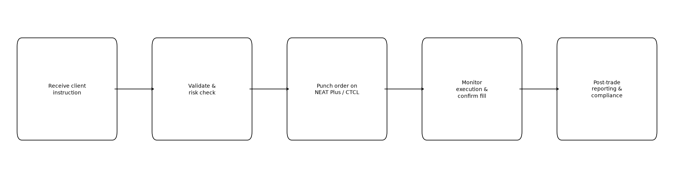
Figure 4: Generalised client order execution workflow followed on the Equity Dealing Desk at Rosy Blue Securities (receive → validate → punch → monitor → confirm).

21. OBSERVATIONS AND FINDINGS
Based on my internship exposure, I observed that successful equity dealing requires close coordination between people (clients and dealers), processes (validation and risk checks) and technology (terminals, RMS and charting).
Client trust depends on timely and accurate execution: a correct price fill is valuable only when it is communicated promptly with quantity, average price and confirmation, and when the dealer proactively flags rejections or partial fills.
I also observed that pre-market preparation and post-market reconciliation are as important as live-market speed, because they prevent errors (wrong expiry/lot) and ensure overnight risk is controlled before the next session.
Knowledge sharing within the dealing desk – regular briefings on new scrip circuits, expiry calendars, terminal shortcuts or recent RMS blocks – can improve consistency and reduce repeated errors. Continuous learning of chart patterns and strategy pay-offs, even without personal trading, helps dealers follow client reasoning and avoid punching mistakes on complex instructions.
Overall, the internship showed me how equity markets blend finance, technology and human discipline in every executed order.
Key Points
- People–process–technology coordination in dealing
- Importance of timely and accurate execution communication
- Value of pre-market and post-market discipline
- Knowledge sharing for consistency
- Finance–technology integration in broking

22. CONCLUSION AND SUGGESTIONS
The Summer Internship Programme at Rosy Blue Securities Pvt. Ltd. provided me with comprehensive practical exposure to Equity Dealing operations. Over the two-month internship, I learned to operate NEAT Plus and CTCL terminals, handle Cash Market and F&O Market orders on behalf of clients as per their guidance, interpret option trading strategies, and read trading charts and technical indicators as part of dealer-supported client service.
The internship helped me understand the criticality of accuracy, speed, communication and risk discipline in a dealing room. Handling daily client instructions and assisting with complex multi-leg orders improved my attention to detail, pressure handling and compliance consciousness.
Assisting senior dealers and explaining terminal basics and chart reading to new joiners further strengthened my communication, mentoring and knowledge-sharing skills. It also deepened my own understanding, because teaching a terminal flow or a strategy pay-off requires clarity about each step and its risk.
From an academic perspective, the internship connected MBA Finance theory (capital markets, derivatives, technical analysis) with live broking operations. It demonstrated how exchange systems, dealer terminals and risk controls support order execution and how dealing teams ensure settlement readiness and client satisfaction.
Suggestions include maintaining a structured, segment-wise playbook for recurring order types (Cash intraday vs delivery, futures vs options) to speed up new-dealer onboarding, continuing regular huddles on expiry calendars and margin changes, strengthening the link between dealing and risk teams for faster block resolution, and continuing simulated trading drills (mock) to practice fast-market punching without client risk.
Key Points
- Continue structured dealing playbook and onboarding
- Maintain knowledge documentation for recurring instruction types
- Encourage dealing–risk coordination
- Use systematic order logging and confirmation tracking
- Continue simulated drills and chart/strategy refreshers

23. BIBLIOGRAPHY
The primary basis for this report is the practical learning, observations and work exposure obtained during the Summer Internship Programme at Rosy Blue Securities Pvt. Ltd., in the Equity Dealing Department.
The report also follows the academic requirements and structure of the Summer Internship Programme prescribed for the MBA – Finance programme of the University of Mumbai and Navinchandra Mehta Institute of Technology and Development.
Key Points
- Summer Internship Programme experience at Rosy Blue Securities Pvt. Ltd., Equity Dealing Desk
- Academic guidance provided by Navinchandra Mehta Institute of Technology and Development
- Personal work observations, dealer shadowing and learning logs maintained during the internship

24. APPENDIX – ACTIVITY MATRIX
The following matrix summarises the major activities covered during the internship as an Equity Dealer. It is intended as a quick reference to the terminal, market, analytical and client-service scope of the training.
Area | Activity / Exposure | Nature of Work
Trading Terminals | NEAT Plus terminal | Terminal operation & execution
Trading Terminals | CTCL terminal | Terminal operation & execution
Cash Market | Intraday & delivery, T+1 settlement | Market operations & execution
Cash Market | Circuit filters & corporate actions | Market awareness & risk
F&O Market | Futures contracts (lots, expiry, MTM) | Derivatives operations
F&O Market | Option contracts – calls & puts | Derivatives operations
Client Execution | Buy orders on behalf of clients (as per guidance) | Order handling & execution
Client Execution | Sell orders on behalf of clients (as per guidance) | Order handling & execution
Option Strategies | Single-leg & hedged (covered, protective) | Strategy learning & application
Option Strategies | Spreads, straddle/strangle, iron condor | Strategy learning & analysis
Trading Charts | Candlesticks, OHLC, volume, support/resistance | Technical analysis
Trading Charts | Indicators – MA, RSI, MACD, Bollinger, VWAP | Technical analysis
Team & Risk | Senior dealer shadowing & RMS/compliance | Team coordination & compliance
Learning | Pre-market prep & post-market reconciliation | Operational discipline & knowledge sharing

